Evidence-Centered Classroom Assessment –
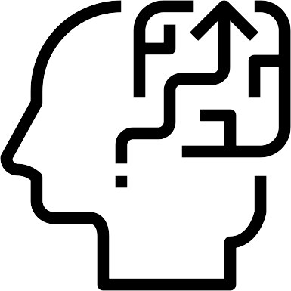
Activity Name:
Description:
Target Competencies/Objectives/Standards:
Prompt:
Other Stimulus Material: .
Expected Work Product:
Relevant Evidence Rules:
Task Features:
Manipulable Feature  Time of lesson, challenge of items | Possible Values  Grade level, # of digits | Affects Height/Depth of Competency  DOK 1-4 | Affects Which Competencies  Comprehension, reasoning | Affects Discrimination Challenges unrelated to skill | Affects Difficulty  Easier, moderate, challenging
Links to other skills:
Related Standards and Objectives:

